**CSci 384: Artificial Intelligence** Spring, 2015

Instructor: Dr. E. Kim Date: April 2nd, 2015

**Due: 3:00 PM, April 14th (Tue.), 2015.**

**Home Assignment 3: FOL & Inference in FOL (96/ 150 points)**

**Q1.** 5/ [10] Find the **MGU** (most general unifier) in each pair of sentence below or justify why unification is not possible.

1. 5 Wines(x, x) vs. Wines(Chianti, Cabernet x)

This one won't work because x is the same as x but Chianti and Cabernet are not equal so unification on this cannot work

1. 0 Wines(x, y) vs. Wines(y, x)

They will probably give the same results so unification is possible but the same thing happens in both θ={x/y} or {y/x}

**Q2. 2/**  [10] Convert the following sentence in FOL to the sentences in **CNF**.

w { [(***➢***P1(w)  ***➢***P2(w))  P3(w)]  [ x y (***➢***P3(x,y)  P4(w, x))]}  [w P5(w)].

Standardize Variables:

w { [(*¬*P1(w)  *¬*P2(w))  P3(w)]  [ x y (*¬*P3(x,y)  P4(w, x))]}  [z P5(z)]

Skolemization:

w { [(*¬*P1(w)  *¬*P2(w))  P3(w)]  [(*¬*P3(F(w), G(w))  P4(w, F(w)))]}  [z P5(z)]

Drop universal quantifiers:

[(*¬*P1(w)  *¬*P2(w))  P3(w)]  [(*¬*P3(F(w), G(w))  P4(w, F(w)))]  [P5(z)]

Distribute  over :

[*¬*P1(w)  P3(w)  *¬*P3(F(w), G(w))  P4(w, F(w))]

 [*¬*P2(w)  P3(w)  *¬*P3(F(w), G(w))  P4(w, F(w))]

 P5(z)

**Q3. 12/** [15] Write down the following sentences in the 1st -order logical representations, suitable for its use with *Generalized Modus Ponens*, i.e. in Horn clauses. Do not convert them in CNF.

1. x (H(X)C(x)P(x)) => M(x)
2. x z (H(z) ~~~~ **∧** O(x,z)) => H(x) -1
3. H(Bluebeard)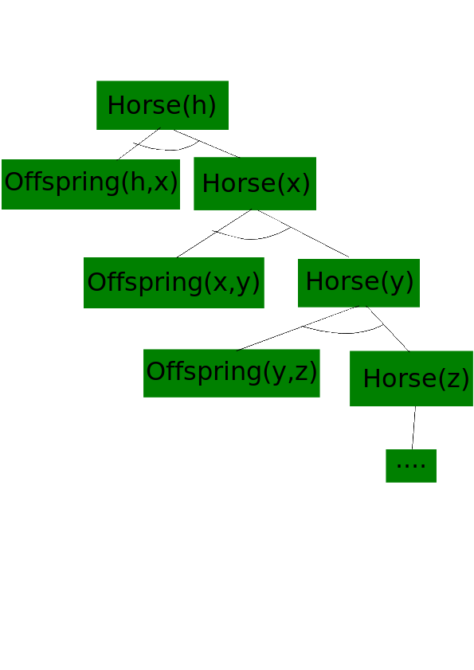
4. P(Bluebeard,Charlie)
5. x z O(x,z) <=> P(z,x)
6. x Mammal(x)  y Parent(y,x) -2

**Q4. 22/** [30 pt] From the sentences you wrote in Q3, answer the following question using a ***backward-chaining algorithm***.

1. 7/ [10] Draw the proof tree generated by a backward chaining algorithm for the query  *h,*  *Horse(h),* where clauses are matched in the order given.

Please show the substitution of the variables. -3

1. 10 It is infinite
2. 5 From my solution there is only one solution for h 2 solutions. {h/Bluebeard} and {h/Charlie}

**Q5. 23/** [30] From ”Horses are animals”, it follows that ”The head of a horse is the head of an animal.”.

Demonstrate that this inference is valid by carrying out the following steps:

1. 8/ [10] Translate the premise and the conclusion into the language of 1st -order logic. Use three predicates:

x Horse(x) => Animal(x)

h x (Horse(h)  HeadOf(x,h)) ~~=> (Animal(h) HeadOf(h,x))~~ => a (Animal(a)  HeadOf(~~h~~, x, a)) -2

1. ***  ➢***Horse(x)  Animal(x)

Horse(G)  HeadOf(H,G)  ( ***➢***Animal(y)  ***➢***HeadOf(H,y) ) No intermediate steps?

¬∀x ∀h {[Horse(x)  HeadOf(h, x)]  ∃y [Animal(y)  HeadOf(h, y)]}

≡ ∃x ∃h ¬{[Horse(x)  HeadOf(h, x)]  ∃y [Animal(y)  HeadOf(h, y)]}

≡ ∃x ∃h ¬{¬[Horse(x)  HeadOf(h, x)]  ∃y [Animal(y)  HeadOf(h, y)]}

≡ ∃x ∃h {[Horse(x)  HeadOf(h, x)]  ¬∃y [Animal(y)  HeadOf(h, y)]}

≡ ∃x ∃h {[Horse(x)  HeadOf(h, x)]  ∀y ¬[Animal(y)  HeadOf(h, y)]}

≡ ∃x ∃h {[Horse(x)  HeadOf(h, x)]  ∀y [¬Animal(y)  ¬HeadOf(h, y)]}

≡ Horse(G)  HeadOf(H, G)  [¬Animal(y)  ¬HeadOf(H, y)]

1. *** ➢***HeadOf(H,y), HeadOf(H,G) == ***➢***Animal(G)

*➢*Animal(G),***➢***Horse(x)  Animal(x) == ***➢***Horse(G) incomplete -5

Horse(G), [¬Horse(x)  Animal(x)] ⊢ Animal(G) ={x/G}

Animal(G), [¬Animal(y)  ¬HeadOf(H, y)] ⊢ ¬ HeadOf(H, G) ={y/G}

¬ HeadOf(H, G), HeadOf(H, G) ⊢ *empty* clause

={x/G, y/G} Finding a substitution is how a pair of clause can be resolved.

**Q6. 29/** [40] Given sentences (A – E) below,

* 1. All great chefs are Italian.
  2. All Italians enjoy good food.
  3. Michael or Louis is a great chef.
  4. Michael is not a great chef.
  5. Query: Who enjoys a good food?

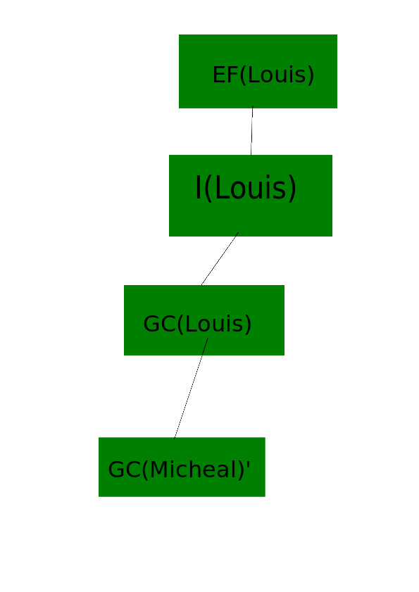

1.   x GC(x) => I(x)

x I(x) => EF(x)

GC(Michael)  GC(Louis)

***➢***GC(Michael)

~~EF(Louis)?~~ **z** EF(z)? -2

1. 8/ [10] Answer the query by 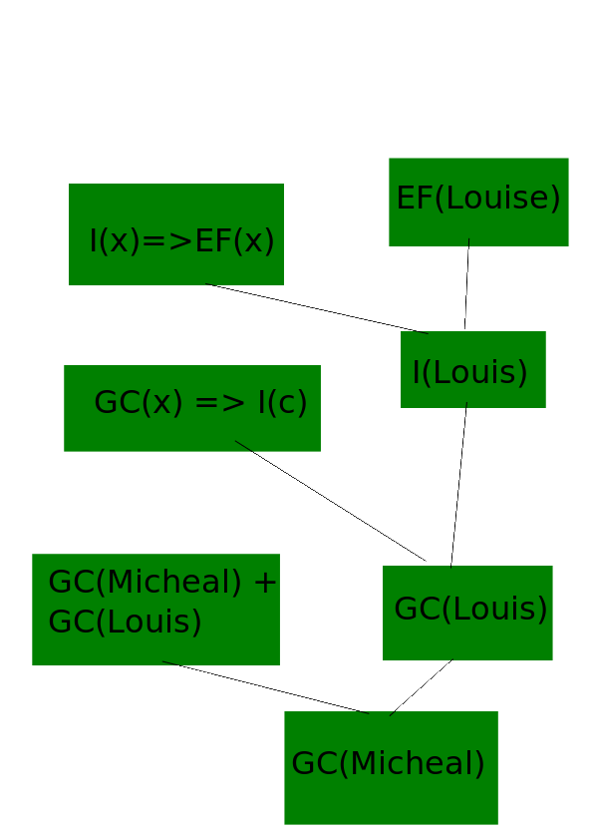***forward chaining*** method. Draw the proof trees showing the substitutions step by step. Refer to the slide #23 - #25.

You should find a substitution {z/Louis} to answer the query. -2

1.  ***➢***GC(x)  I(x)

***➢***I(x)  EF(x)

GC(Michael)  GC(Louis)

1. 3 Negation of query: ***➢*** EF(z)

***➢***GC(Michael), GC(Michael)  GC(Louis) == GC(Louis)

GC(Louis), ~~x GC(x) => I(x)~~ ***➢***GC(x)  I(x) == I(Louis) θ={x/Louis}

~~x I(Louis) => EF(Louis)~~

I(Louis) , ***➢***I(x)  EF(x) == EF(Louis) θ={x/Louis}

EF(Louis), ***➢*** EF(z) == empty clause θ={z/ Louis, x/Louis}

Thus, z= Louis enjoys a good food.

You should use clauses by eliminating implications, not a form of implication.

**Q7.** **3/** [15] Suppose that the sentence A in Q5 is changed to: (I assume you meant in Q6)

A’. *Some* great chefs are Italian.

1.   x GC(x) => **∧** I(x)
2. ***  ➢***GC(x)  I(x) GC(K), I(K) x is Skolemized by a constant K.
3. *** ➢***GC(Michael), GC(Michael)  GC(Louis) == GC(Louis)

GC(Louis), x GC(x) => I(x) == I(Louis) (we cannot be sure about this so we cannot be sure about this step so there for we cannot be sure about the next step)

x I(Louis) => EF(Louis)

Substitution {z/ K}is found during an inference where K is Skolem constant.

i.e. it simply answers ‘someone enjoys good food’, but doesn’t answer Louis enjoys good food.

So, inference is usuccessful.